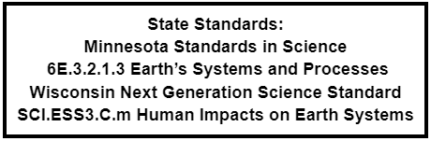
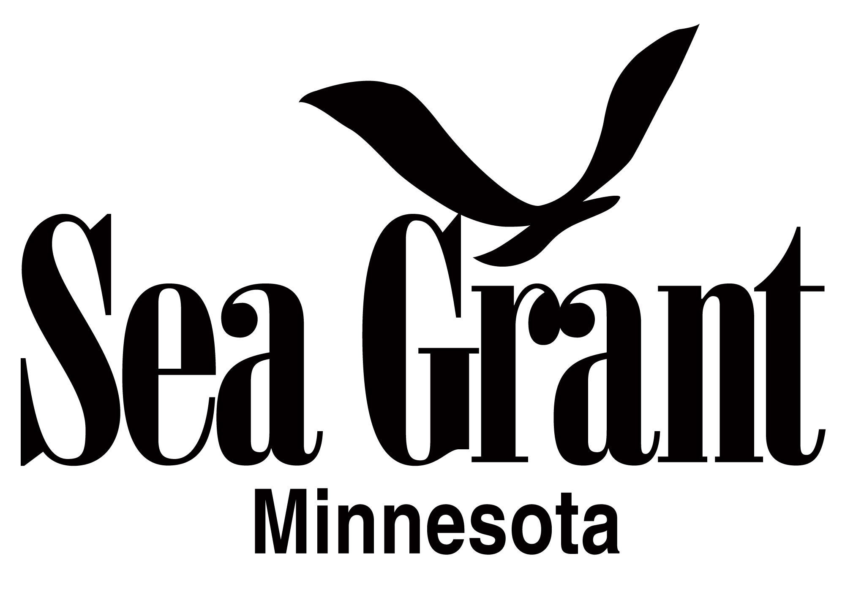
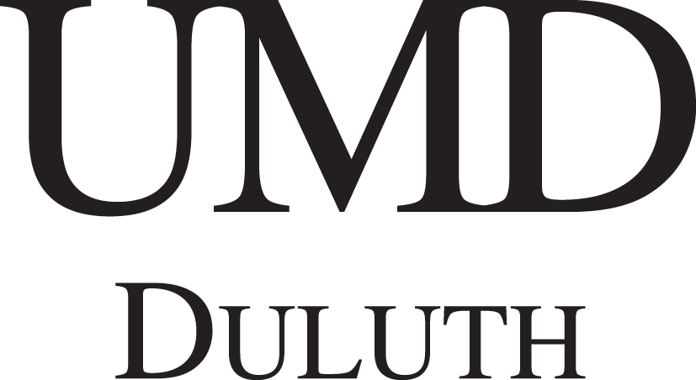

River Quest
What is the Solution to Pollution?
Synopsis, Resource Links, and Vocabulary
Contact: Kelsey Prihoda, University of Minnesota Sea Grant College Program
priho011@d.umn.edu
Jamie Tigges, University of Minnesota-Duluth Masters of Environmental Education Program and University of Minnesota Sea Grant College Program
tigge025@d.umn.edu

Synopsis:
Chocolatey milk brown water after a storm, slimy squish feeling between your toes, or even the feeling of sandpaper. These are all examples of sediment being transported and deposited in our aquatic ecosystems! But that’s not all that is being locked away on lake bottoms. Chemicals and debris may also be transported into water bodies and get stuck in the mud. How do we identify what is harmful to humans and other living organisms? More importantly, how do we remove these from the environmental systems they pollute? This station will introduce students to a monitoring program, the Great Lakes Sediment Surveillance Program (GLSSP), whose goal is to locate and identify pollution in the mud at the bottom of the Great Lakes. Students will help clean up pollution and in doing so will learn why some pollutants are harder to remove from the mud than others.

References Materials:
- Per and Polyfluoroalkyl substances https://www.epa.gov/pfas
- Great Lakes Smelt Advisories: https://www.bridgemi.com/michigan-environment-watch/lakes-michigan-and-huron-join-list-lakes-pfas-tainted-smelt
- St. Louis River AOC cleanup https://www.epa.gov/newsreleases/epa-cleanup-continue-st-louis-river-area-concern-superior-wisconsin
- Dredging restrictions: https://www.stlouisriverestuary.org/images/restoration/bui5.pdf
- Microplastics in lake sediments: https://www.nature.com/articles/s41598-020-57933-8
- Contaminants in Great Lakes sediments: https://www.csu.edu/cerc/researchreports/documents/GreatLakesSedimentsContaminationToxicityBeneficialReUse.pdf
- Information on the Great Lakes Sediment Surveillance Program:
  - Monitoring on Lake Superior in September 2021
  - Burlakova et al. (2018). U.S. EPA Great Lakes National Program Office monitoring of the Laurentian Great Lakes: Insights from 40 years of data collection. Journal of Great Lakes Research: 44(4): 535-538. https://doi.org/10.1016/j.jglr.2018.05.017

Vocabulary List:
Contaminant
Dredging
Aquatic vs Marine Ecosystems
Point-Source
Deposition
Transportation
Fertilizer
Emergent
Legacy
Sediment
Sequestration
Stratification

